Merivale Papanui Cricket Club

Established

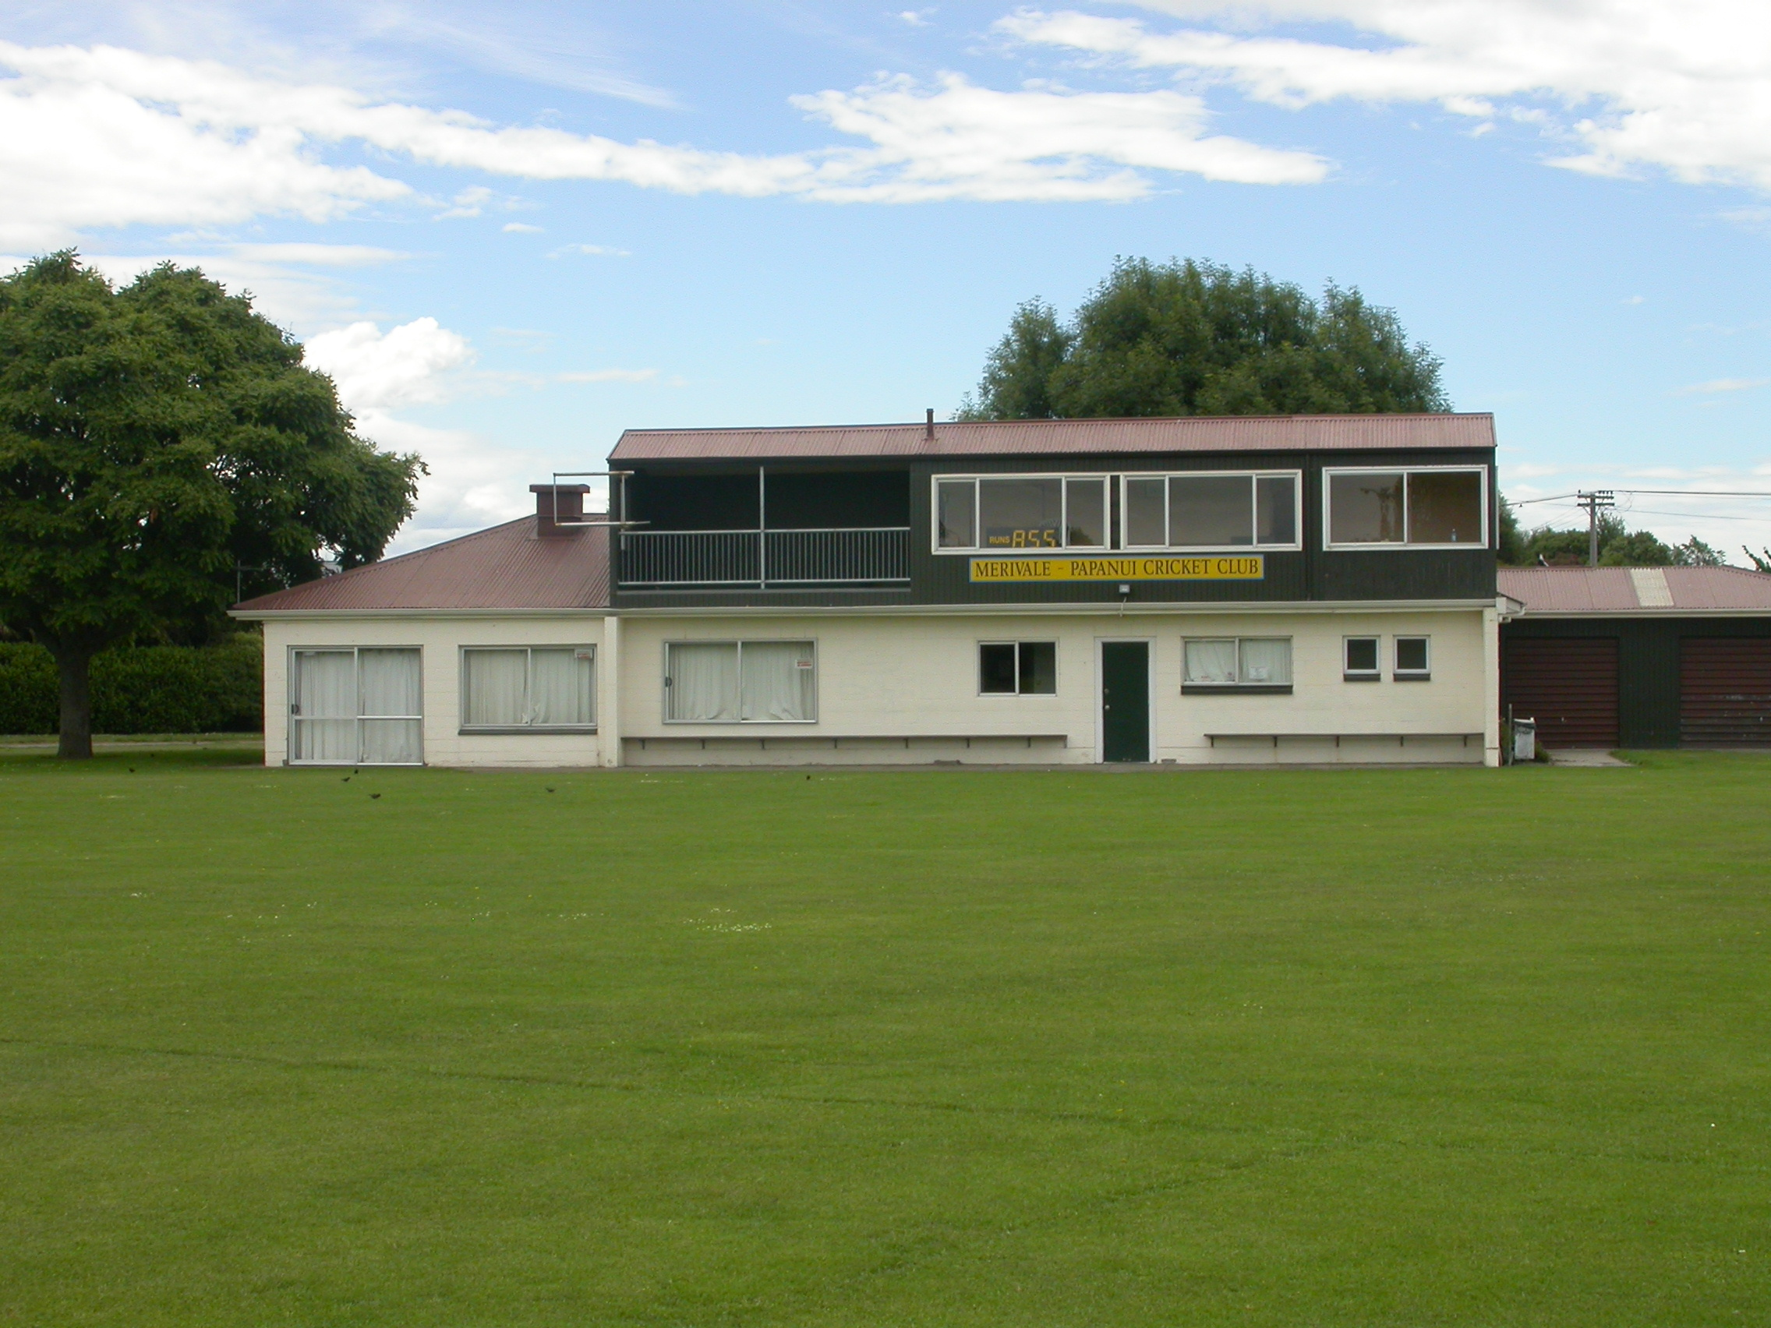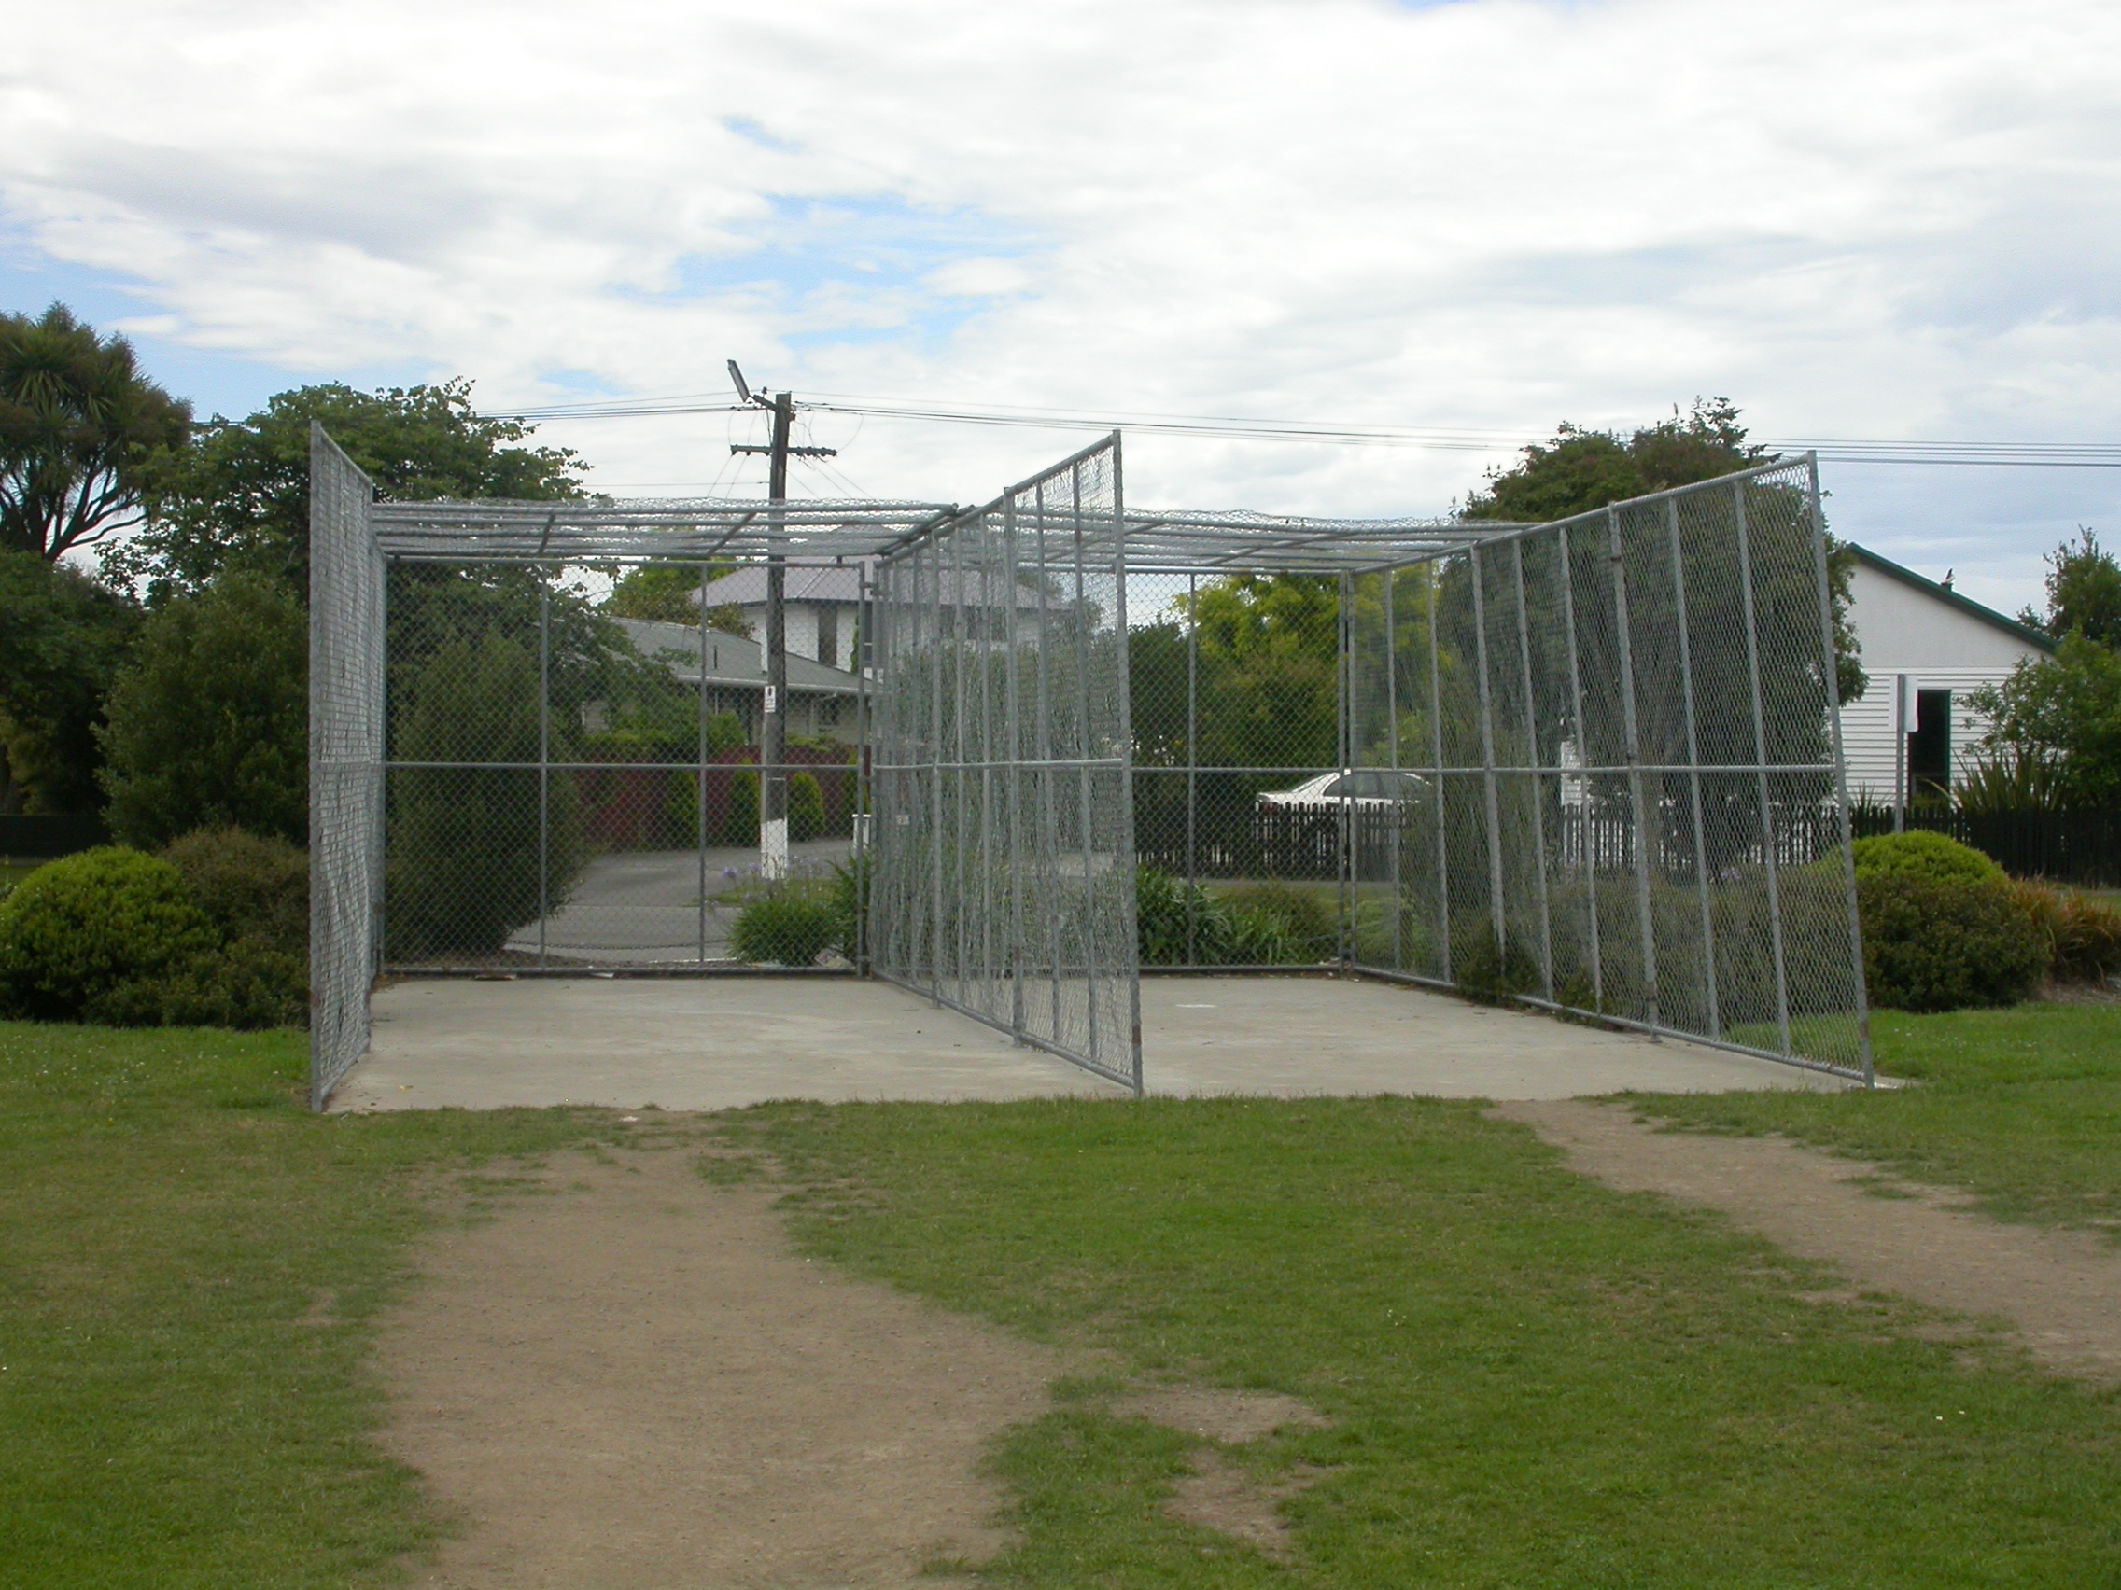

Home Ground Edgar MacIntosh Park
Match pitches 3 grass match pitches
Practice pitches 2 artificial pitches
Secondary ground Bishopdale 1 grass pitch

Entries 2001-02 5 men teams 8 junior teams
2002-03 6 men teams 6 junior teams
2003-04 6 men teams 7 junior teams
2004-05 7 men teams 1 women team 6 junior teams
2005/06 7 men teams 1 women team 10 junior teams

Grade wins last 5 years 2000-01 Fourth D
2001-02 Senior B

